**CS691 - Computer Science, Spring 2016**

**Project Initiation Document**

Project: Hungry Alarm

Project Manager: Xing Chen

Start Date: 2/4/2020

Completion Date: 4/27/2020

Table of Contents

Document Purpose 4

Background to the Proposed Work 4

Vision 4

Project Objectives 5

Project Scope 5

Business Case 6

Assumptions 8

Constraints 8

Risk Management Strategy 9

Deliverables 10

Stakeholders 11

Project Team 11

Project Plan 14

Project Controls 15

Communication Plan 15

Document Details

|  |  |  |  |
| --- | --- | --- | --- |
| Version | Modifications | Author | Date |
| 1 | Initial PID Document | Team 1 | 2/7/2020 |
| 2 | Initial PID Document | Team 1 | 2/11/2020 |
|  |  |  |  |
|  |  |  |  |

Approvals

This document requires the following approvals:

|  |  |  |  |  |
| --- | --- | --- | --- | --- |
| Name | Role | Signature | Date | Version |
| Xing Chen | Project Manager |  |  |  |
| Mojin Zhang | Product Owner |  |  |  |
| Saraluk Kaiwansakul | Lead Business Analyst |  |  |  |
| Te-Yi Tsai | Lead Developer |  |  |  |
| Eric Chen | DBA |  |  |  |
| Qiang Xu | Lead QA Analyst |  |  |  |
| Yuri Chernak | Professor |  |  |  |

Distribution

This document has been distributed to:

|  |  |  |  |
| --- | --- | --- | --- |
| Name | Role | Date of Issue | Version |
| Xing Chen | Project Manager | 2/7/2020 | 1 |
| Mojin Zhang | Product Owner | 2/7/2020 | 1 |
| Saraluk Kaiwansakul | Lead Business Analyst | 2/7/2020 | 1 |
| Te-Yi Tsai | Lead Developer | 2/7/2020 | 1 |
| Eric Chen | DBA | 2/7/2020 | 1 |
| Qiang Xu | Lead QA Analyst | 2/7/2020 | 1 |

# Document Purpose

This document is the Project Initiation Document (PID) for Hungry Alarm. The purpose of this document is to serve as the guideline of how the project will be managed throughout the entire process to make sure the final success. It will explain the objectives of the project along with the required deliverables, constraints, risk management, and the responsibilities of each team members.

This document will cover the following areas:

* The approach to be adopted for the implementation of the Hungry Alarm project
* Details of the application functions
* Details of the roles and responsibilities of team members
* Description of the processes and products that affect the overall performance of the business
* Risk management, quality control and exceptions
* Communication plan

Certain sections of this document may change during the lifetime of the project; however, all the changes will be recorded in the document. The PID document will be referred whenever the team is working on the project to make sure all the deliverables are produced on time and whether the project is successfully managed at the end of the semester.

# Background to the Proposed Work

Everyday we ask ourselves the same questions - What to eat for lunch? Where should we go for dinner? I am tired of eating the same food everyday, is there any new place? Let’s go grab coffee, but where do you want to go? “Hungry Alarm” is the solution for all those types of questions. It is designed for both users and restaurant owners. The application interface will allow users to create a profile, add restaurant preference, make reservations, filter restaurant type, look for discount, etc. The restaurants will increase its traffic by offering special coupons or membership programs to the app users.

This project will provide users with the features and tools necessary for restaurant search. It will increase the variety of meal options, make hanging out with friends a lot more fun, help people save both time and money on a daily basis.

# Vision

The goal of this project is to design a daily use application for restaurant search. It is a simple solution for the most frequently asked question “what to eat.” This is a food profession application which enhances the user’s experience of making a decision on each meal and expectation of food they are going to eat.

# Project Objectives

This section includes how the purpose of the project breaks down into individual objectives and the specific, measurable results expected upon project completion.

Objectives in this section need to be outlined in a way that will enable them to measure the success of the project.

To resolve the issue of “what to eat”, our app is going to present the daily discounts, recommendation and customized restaurant searching engine. Unlike ‘yelp’, our app is going to focus on the food and restaurant, deals, events like happy hour, free desserts, etc.

After helping users decide what to eat, we want to improve users dining experience by matching users’ expectation of food and actual food. The app will provide accurate information (what it tastes like, clear picture) about each dish from restaurant to restaurant.

We also want to create a food community where users can interact with others and share information about what they eat, including restaurants they went to and delivery orders they made. In the community, users can post pictures of the food which his/her friends can see on the app. There will also be some popular food bloggers that users can follow to check out food reviews they write about.

# Project Scope

Our project scope includes major functionalities provided by the application as follows.

* The application has sign up and log in functionalities for both users and restaurant owners.
* Display all restaurants nearby users’ current location with special deals/ events details that are offered at the moment.
* Users can search for specific deals/events, cuisines and restaurant types.
* The application provides various filter options.
* Users can mark their favorite restaurants and will receive email notifications for new deals/events from those restaurants.
* Users are able to make reservations with the offered deals and receive email confirmation once the reservations are successfully completed.
* A list of all upcoming reservations that users have made through the platform.
* Rating and giving review are available for users.
* Restaurant owners can post special deals/ events that they offer.
* Restaurants will receive notifications with reserved information when users have successfully made reservations.
* Provide restaurants with statistical reports on deals/ events they have posted for future improvement.

# Business Case

Hungry Alarm is a platform focused on providing users with a medium to explore restaurants in their neighbourhood. Restaurant owners are able to create their own profile pages on Hungary Alarm with information such as deals and promotions, happy hours, and reservation information, this helps increase restaurants exposure beyond their physical reach through advertising on the platform. Users are able to easily browse restaurants, compare deals, and book reservations through the platform. Whenever a user book a reservation through the platform, Hungry Alarm will charge the restaurant a predetermined commission fee.

|  |  |
| --- | --- |
| **Application Name** | Hungry Alarm |
| **Type of business model** | Advertising, Freemium, Brokerage |
| **Target audience of external users**  **(Customer Segments)** | Working class looking for a quick meal, happy hour, restaurant deal, a close place for business lunch/ dinner, etc.  Restaurants looking for a platform to promote events and deals. |
| **Groups of internal stakeholders, users** | A product development group will utilize cross-platform model to design the application.  A sales team is needed to reach out to restaurants and negotiate advertising fee, event promotion, etc.  A finance group is responsible for managing the internal and external costs and revenues. |
| **Value propositions** | Trying to build a connection between restaurants and customers.  Bringing traffic to restaurants which offer regular deals/ events and try to increase awareness of local customers.  Offering good deals and new ideas to customers searching for a quick meal and a better business meeting spot. |
| **Key resources** | What Key Resources do our Value Propositions require?  Customer base, restaurants database, hardware and Web/DB software to run the application  Our Distribution Channels?  Our platform provides optimized and customized filter for customers who are searching for specific deals/meals. Real-time updates from restaurants which list promotions and discounts.  Customer Relationships?  Marketing communication, customer service  Revenue Streams?  Advertisement fee from restaurants. Broker fees (paid by a restaurant) when a customer places an order via your portal. |
| **How the system is used** | Mobile Application  Within this application, users will:   * register and sign up for application to create their own profile, add meal preference, etc * search for restaurants which offer current deals that near their locations * mark their favorite restaurants and receive special deal from those restaurants * filter out the type of restaurant they are looking for, e.g. vegan, seafood, BBQ, Italian, buffet, etc. * book reservation at the restaurant * leave reviews for the restaurant on the platform   Restaurants will:   * post their current events and deals on the platform * add photos and restaurant information * receive reviews and ratings from customers * gather loyal customers information and offer special deal to those customers * receive discount on advertising fee if they offer frequent deals on the platform |
| **Revenue generation, Revenue streams** | Charging advertising and promotion fee from restaurants |
| **Key Partners/Suppliers**  **(Stakeholders)** | Restaurants |
| **Expected Benefits** | User side -   * reduce time spent on planning meals and looking for restaurant deals   Restaurant side -   * help restaurants with online promotion and increase exposure * give special deal to loyal customer to increase customer relationship |
| **Known Prototypes** | Yelp.com, Uber Eats, OpenTable, Seated |

# Assumptions

|  |  |  |  |
| --- | --- | --- | --- |
| Assumption | Validated by | Status | Comments |
| Weekly meeting | All members | In progress | meeting up every Friday at 12:30 |
| Workload sharing between team members | Project Manager | In progress | Tasks will be assigned at Tuesday and discuss progress on Friday |
| Document updates after each meeting | Project Manager | In progress | Each member will be responsible for their assigned section and it will be reviewed by the project manager after each meeting. |
| Sufficient software resources | Lead Developer | In progress | Software development languages and softwares will include JavaScript and visual studio code. |
| Sufficient Hardware/ web-service resources | Lead Developer | In progress | Current decisions include using React for frontend and mongoose for backend. |
| Core features will be constant | Project Manager | In progress | Core features have been decided during project initiation with adjunct features that will be further evaluated during productions. |
| Member roles will be fixed but supportive to each other | All members | In progress | Assigned job titles define responsibility but assignment of tasks can be flexible during production. |

# Constraints

* Procurement rule: Freemium app for IOS and Android platform.
* Deadlines: Will follow the time schedule provided.
* Requirements: Will meet project document specifications and methodology.
* Limitations due to other projects or programmes include: Time schedule of each team member.

# Risk Management Strategy

|  |  |  |  |
| --- | --- | --- | --- |
| Risk | Probability | Impact | Mitigation Method |
| Each team member has the right skills for his or her own part | Medium | Medium | Technical -  Pair programming so code will be reviewed by more than one programmer.  Business -  During group meeting, each member can be part of the customer team and brainstorm business plan. |
| Application and System Architecture | Medium | High | Technological risks:  make sure the team includes experts who understand the architecture and have the capability to make sound design choices |
| Organizational risk including loss of staff, communication issues, conflicts in schedules and progress, etc. | Low | High | Make plan for efficient execution of the project and stick to it; adequate staffing and choosing team members with skill sets that are a good match for the project; meet in person weekly or have video conferences to make sure we are on the right track. |

Risk management is critical to the success of this project. The most significant risk that might threaten our project is application and system architecture risk. For example: If the hardware and software we choose are prone to bugs and are slow, they may be inappropriate for developing a system; taking the wrong direction with a platform, component, or architecture might disrupt our development progress. In order to quickly spot and mitigate the risks, we will be holding weekly meeting to reflect the problems raised when completing the previous deliverables. During the meetings, we will brainstorm on potential new risks after changes to project schedule or scope; review and prioritize risks, eliminating those with lowest probability. Also, we will revise risk plans according to any major changes in project schedule to reflect changes. Last but not least, each team member is responsible to keep a project status report and include risk management issues.

Our mitigating options include:

* Accept: for low impact and probability risks, we will acknowledge and accept the risk without any changes to the project, and continue monitor the risk.
* Avoid: adjust project scope, schedule, or constraints to minimize the effects of the risk.
* Control: take action to minimize the impact or reduce the intensification of the risk.
* Transfer: implement an organizational shift in accountability, responsibility, or authority to other stakeholders who will accept the risk.

Risk mitigation planning, implementation, and progress monitoring are depicted in above Figure:

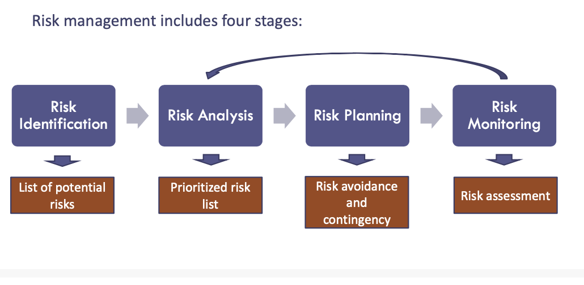

# Deliverables

|  |  |  |
| --- | --- | --- |
| No | Artifact Name | Responsible Party |
| 1 | Project Plan | PM |
| 2 | PID document | PM |
| 3 | BRM Diagram, User Roles | Product Owner |
| 4 | Context Diagram; System Interface Table | Lead BA |
| 5 | Architecture Diagrams (Logical, Process views) | Lead Dev/ DBA |
| 6 | Business Requirements | Product Owner |
| N/A | Functional Decomposition Diagram (FDD), Fishbone Diagram | Lead BA |
| 7 | RCT (func. decomp. suppl. reqs) | Lead BA |
| 8 | Use-Case Diagram (UML) | Lead BA |
| 9 | Activity Diagram (UML) | Lead BA |
| 10 | Data-flow Diagram (logical) | Lead BA |
| 10 | Data-flow Diagram (physical) | Lead BA |
| 11 | Functional Requirements (user stories) | Lead BA |
| 12 | Class Diagram (UML) | Lead Dev |
| 13 | Sequence Diagram (UML) | Lead Dev |
| 14 | ER Diagram (conceptual, logical) | DBA |
| 15 | Table Specifications (Data Dictionary) | DBA |
| 16 | Source Code Sample (Demo), GitHub repository slides (images) | Lead Dev |
| 17 | Test Plan document | Lead QA |
| 18 | Application Demo, Presentation | All |

# Stakeholders

Our stakeholders are categorized into internal and external stakeholders:

|  |  |
| --- | --- |
| Stakeholder | Interest |
| Project Manager (internal stakeholder) | Sets the project vision and strategies; organizes the whole team; monitors team performance and progress; resolves conflicts; reviews deliverables and communicates to stakeholders. |
| Project Team (internal stakeholder) | A product development group will utilize cross-platform model to design the application.  A sales team is needed to reach out to restaurants and negotiate advertising fee, event promotion, etc.  A finance group is responsible for managing the internal and external costs and revenues. |
| Restaurants (external stakeholder) | Potential application users |
| Customers (external stakeholder) | Potential application users |

# Project Team

Team members and assigned roles:

➢ Project Manager - Xing Chen

➢ Product Owner – Mojin Zhang

➢ Lead Developer – Te-Yi Tsai

➢ Lead BA – Saraluk Kaiwansakul

➢ Lead QA Analyst – Qiang Xu

➢ DBA – Eric Chen

Organization Chart:

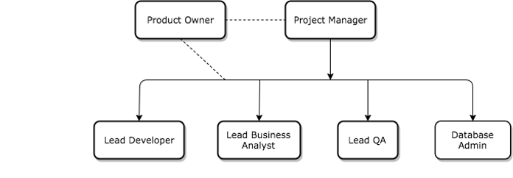

RACI Table:

|  |  |  |  |  |  |  |  |
| --- | --- | --- | --- | --- | --- | --- | --- |
|  |  | **Project Roles** | | | | | |
| **Project Phase** | **Project Tasks** | Project Manager | Product Owner | Lead Developer | Lead BA | Lead QA Analyst | DBA |
| Project Management | Develop a project plan | A,R | C | C | C | C | C |
| Provide cost estimate | A,R | C | C | C | C | C |
| Hire resources | A,R | R | C | C | C | C |
| Establish a project documentation portal | A,R | I | I | I | I | I |
| Maintain a project risk and issue log | A,R | R | C | C | C | C |
| Provide project status reports | A,R | R | R | R | R | R |
| Requirements | Perform requirements analysts | A | R | R | R | I | I |
| Gather business requirements | A | C | I | R | I | I |
| Produce functional requirements | A | C | C | R | I | I |
| Design | Produce high-level design specs | A | I | R | I | I | C |
| Produce data model | A | I | C | I | I | R |
| Produce detailed design specs | A | I | R | I | I | C |
| Coding | Establish a code repository (GitHub) | A | I | R | I | I | I |
| Develop component code | A | I | R | I | I | I |
| Testing | Develop a test plan | A | C | C | C | R | C |
| Establish a test repository | A | I | C | I | R | C |
| Develop test specifications | A | I | C | I | R | I |
| Execute testing, report defects | A | I | I | I | R | I |
| Conduct defect review calls | A | C | R | I | R | I |
| Produce, deliver defect metrics | A | I | C | I | R | I |
| Support test environments | A | I | R | I | C | R |
| Deployment | Produce a deployment plan | A | I | R | I | I | R |
| Produce deployment procedures | A | I | R | I | I | R |
| Deploy software into production | A | C | R | C | C | R |

# Project Plan

The development of Hungry Alarm will follow the agile methodology. With each sprint we will conduct collaboration with stakeholders and team members to acquire feedback for improving user experience and adjustment for features. Sprints will be taking place every now and then to shape and refine our application. The time schedule is provided as below:

Project review: Looking for day to day meals is alway a task during the day. Tasks like thinking what to eat for lunch, planning for a business meal, arranging a restaurant for a date etc. Hungry alarm gives the local customer an idea or suggestion for what to eat for the day, information including: local restaurant special deal, happy hour and special discount during the day. It also focuses on user preference to suggest the best idea for food for the day.

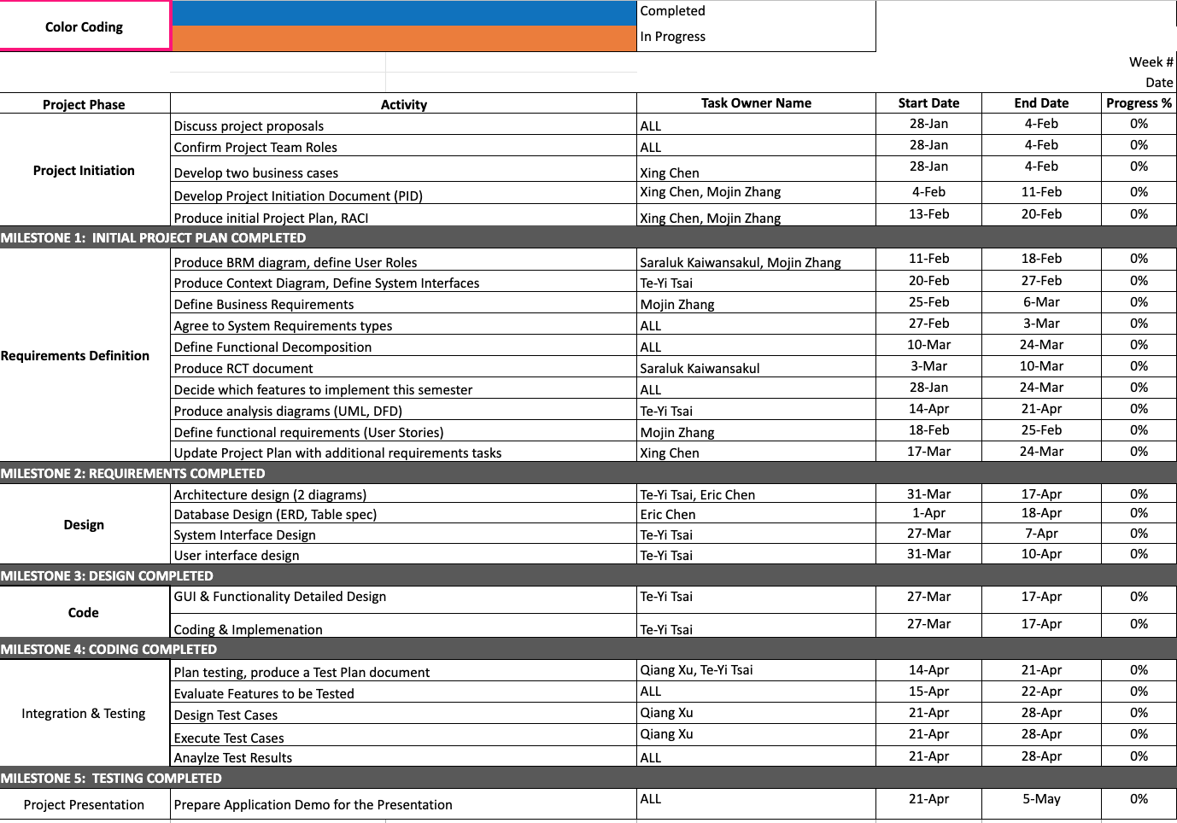

# Project Controls

* As for our weekly meeting, we will meet every Friday at 12:30pm. Each team member has to finish the assignment based on the deliverable schedule, and the peer review will be done to make sure the assignment meets the project requirement. Another optional meeting will be held during the weekend through online meeting if there is anything left to wrap up. At the end of each meeting, the team will discuss the deliverables for next week along with new ideas or questions for the project.
* Project manager will be the main person to communicate with the professor and send feedback to all the team members.
* All the communications will be done through whatsapp, slack, and email.
* Google drive is used to help each team member collaborate on the project.
* Source code will be uploaded to GitHub.

# Communication Plan

This section will include how stakeholders will be communicated with during the project and how frequently. This should include a note on where to find the Communications Plan if you have one.

|  |  |  |  |
| --- | --- | --- | --- |
| Stakeholder | Frequency | Type | Purpose |
| Project Manager | Daily | Slack, email, meetings, phone. | Management of group meeting and project progress, arrangement of personnel and work assignment. |
| Project Team Members | Daily | Slack, email, meetings, phone. | Discuss and complete assigned tasks to produce a fully functional application. |
| End User | Potentially during the testing phase and after release. | Testing sessions, email. | Provide feedback for application experience. |
| Quality management team | Daily | Email, meetings, phone. | Assure application quality meets feature goals and end user requirements. |